PRN NO: 260245920034

- Retrieve the entire contents of EMP table.
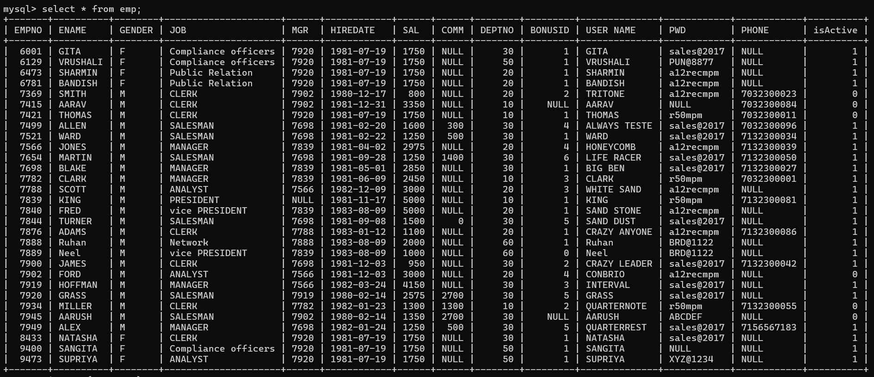
mysql> select * from emp;

- Print the name of employees.

mysql> select ename from emp

- Retrieve the list of names and jobs of employees.

mysql> select ename, job from emp;

- List of various department available from dept table.
mysql> select DNAME from dept;


- List all information about the Employees of the EMP table.
mysql> select * from emptable;


- Show the information of the Department table.
mysql> select * from dept;

- Display the contents of the column Empno, Ename as Employee Name and Sal from the Emp table.

mysql> select Empno Employee_Name, ename, sal from Emp;

- Display the Job, Comm and Ename from the Emp table with Customized column headings.

mysql> select job JOB_ROLE, comm Commission, ename Employee_Name from emp;

- Display the location as “Location” and names of all the departments as “Department Names”.
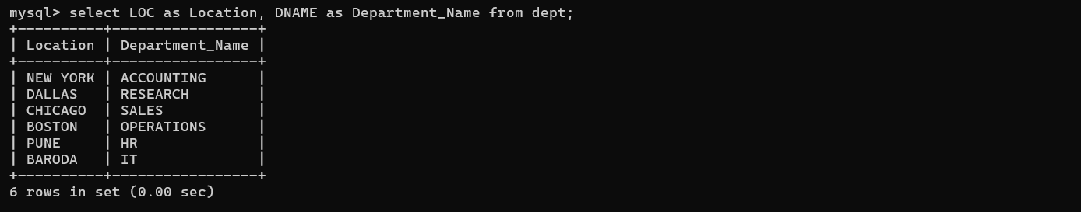
mysql> select LOC as Location, DNAME as Department_Name from dept;

- List the different Managers Codes.
mysql> select mgr from emp;

- Write a query, which concatenates the Emp No, Name and Mgr Code. Display output with spaces in the columns.

mysql> select concat(EMPNO, ' ', ENAME, ' ', MGR) as EMP_DETAILS from emp;

- Create a query to display all the data from the EMP table, separate each column by a comma.
SELECT CONCAT_WS(',',
IFNULL(EMPNO,'NULL'), IFNULL(ENAME,'NULL'), IFNULL(GENDER,'NULL'),
IFNULL(JOB,'NULL'), IFNULL(MGR,'NULL'), IFNULL(HIREDATE,'NULL'),
IFNULL(SAL,'NULL'), IFNULL(COMM,'NULL'), IFNULL(DEPTNO,'NULL'),
IFNULL(BONUSID,'NULL'), IFNULL(`USER NAME`,'NULL'), IFNULL(PWD,'NULL'),
IFNULL(PHONE,'NULL'), IFNULL(ISACTIVE,'NULL')
) AS EMP_DATA
FROM EMP;


- Modify the above query to add a column that will subtract the Old Salary from the New Salary.
SELECT
CONCAT_WS(',',
EMPNO, ENAME, GENDER, JOB, MGR, HIREDATE, SAL, COMM, DEPTNO, BONUSID,
`USER NAME`, PWD, PHONE, isActive
) AS EMP_DATA,
(SAL - 2000) AS SALARY_DIFF
FROM emp;

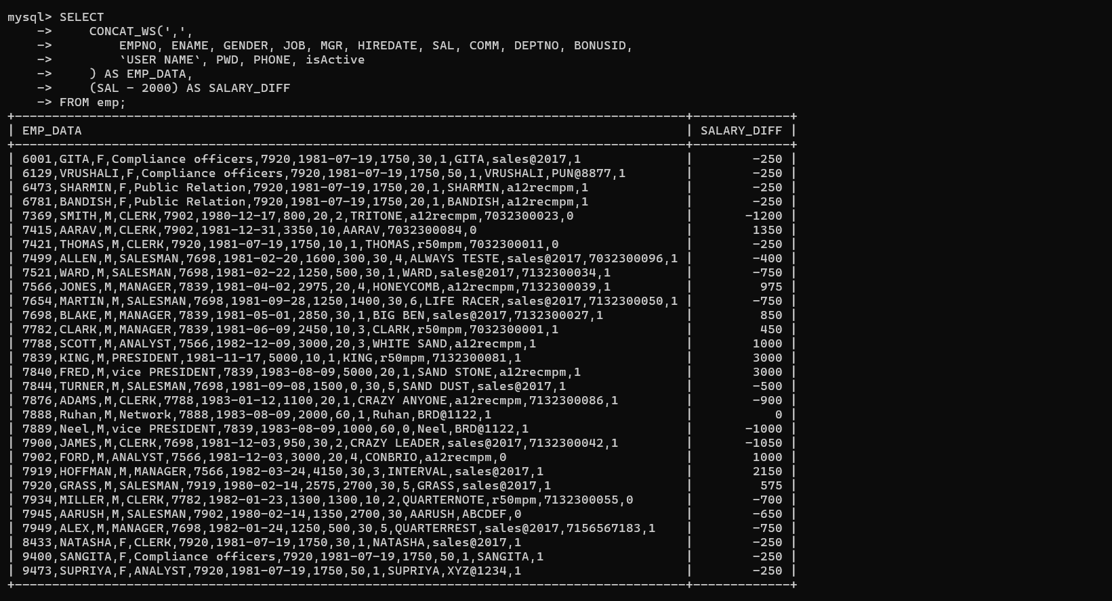

- Write a query that produces the following for each employee as-
<employee name> earns <salary> monthly, but wants salary <3 times salary>. Label the columns Dream Salaries.
mysql> select concat(ename, ' earns ' , sal, ' monthly, but wants salary ', (sal*3)) as 'Dream Salaries' from emp;

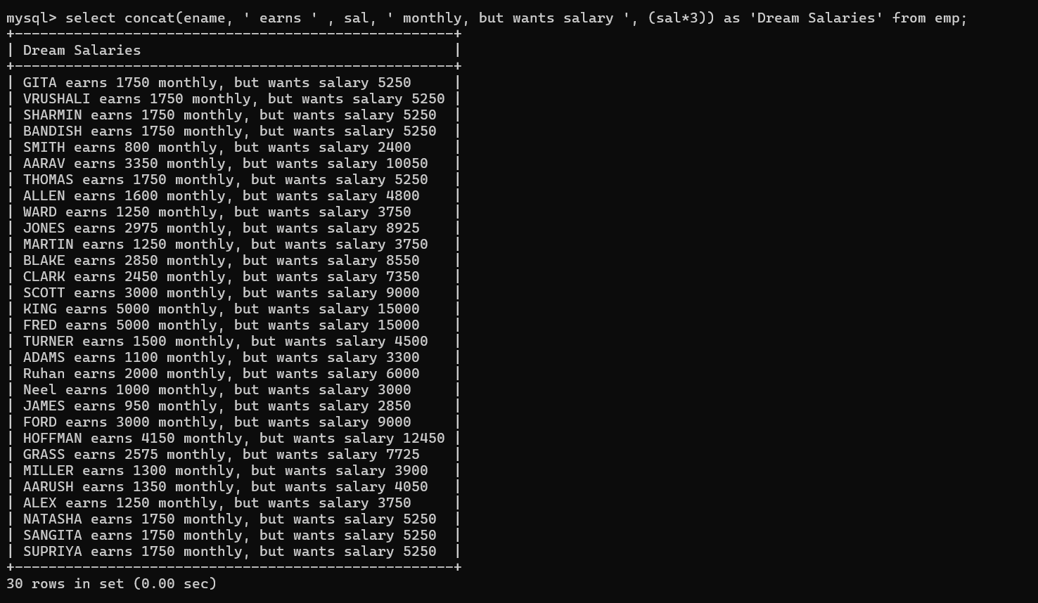
- Display different types of positions available in the Company.
mysql> select JOB as POSITIONS from emp;


- Using the sales table, you need to report the following
  - Appropriate column heading should be given for all the columns.
SELECT
REPID AS `Sales Rep ID`,
CUSTID AS `Customer ID`,
CUSTNAME AS `Customer Name`,
PRODID AS `Product ID`,
PRODNAME AS `Product Name`,
AMOUNT AS `Sales Amount`
FROM sales;

